If … Else

Python Conditions and If statements

* Equals: a == b
* Not Equals: a != b
* Less than: a < b
* Less than or equal to: a <= b
* Greater than: a > b
* Greater than or equal to: a >= b

An "if statement" is written by using the if keyword.

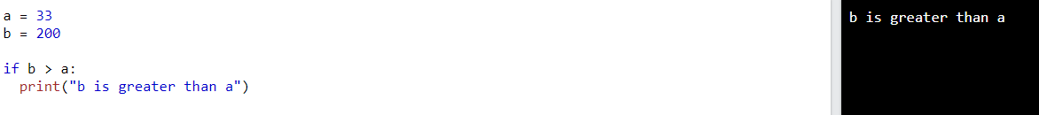

Indentation

Python relies on indentation (whitespace at the beginning of a line) to define scope in the code.

If you don’t use it you will get a error

Elif

The elif keyword is Python's way of saying "if the previous conditions were not true, then try this condition".  
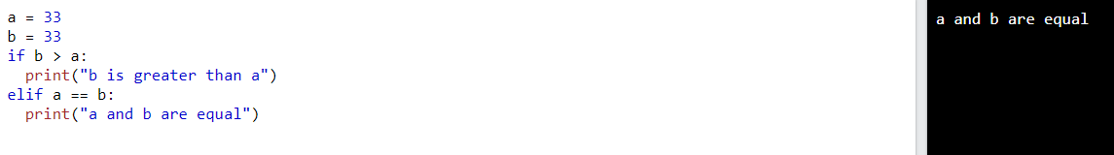

Else

The else keyword catches anything which isn't caught by the preceding conditions.

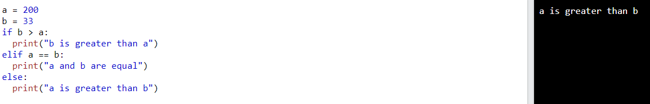

You can also have an else without the elif:  
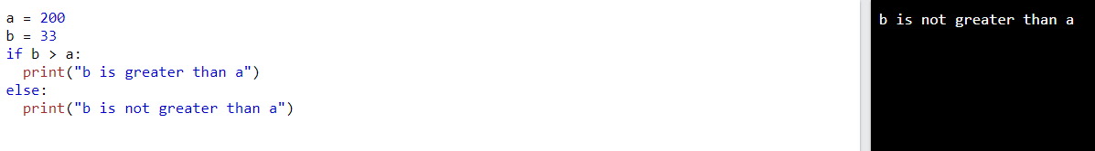

Short hand if

If you have only one statement to execute, you can put it on the same line as the if statement.



Short hand if … else

If you have only one statement to execute, one for if, and one for else, you can put it all on the same line:

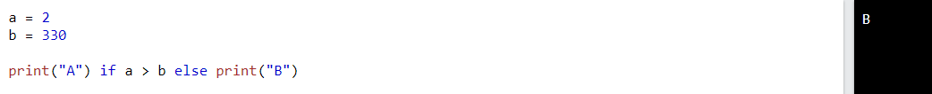  
This technique is known as Ternary Operators, or Conditional Expressions.  
  
You can also have multiple else statements on the same line:  
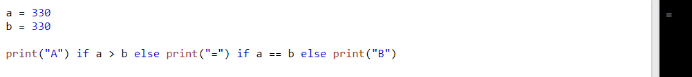

And

The and keyword is a logical operator, and is used to combine conditional statements:

Test if a is greater than b, AND if c is greater than a:  
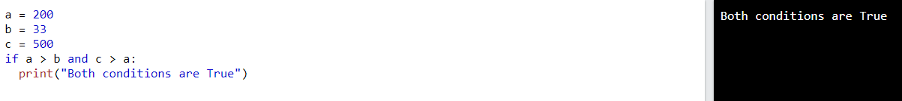

Or

The or keyword is a logical operator, and is used to combine conditional statements:

Test if a is greater than b, OR if a is greater than c:  
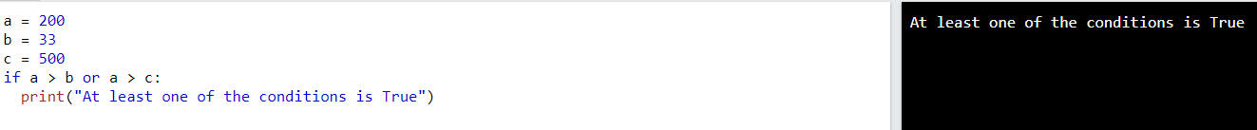

Not

The not keyword is a logical operator, and is used to reverse the result of the conditional statement:

Test if a is NOT greater than b:  


Nested if

You can have if statements inside if statements, this is called nested if statements.

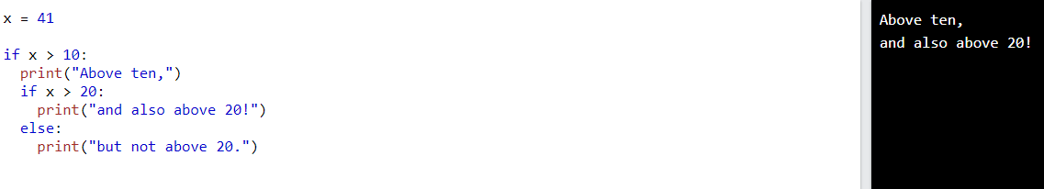

The pass statement

if statements cannot be empty, but if you for some reason have an if statement with no content, put in the pass statement to avoid getting an error.

